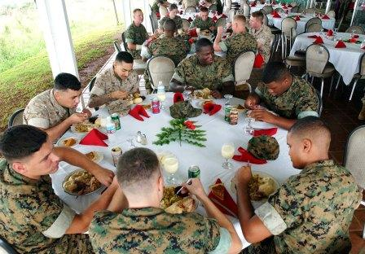

Mess Deck Request

Point of Contact for Event: _____________________

Date of Event: _______________________________

Time of Event: ______________________________

During what meal will the Event take place?

___________________________________________

Number of Guests Attending: __________________

Would you like the tables in a horseshoe formation or a line formation?
*Note >40 guests must use line formation of tables ___________________________________________

Are Tablecloths required for Event? _____________

Is a Podium required for the Event? ______________

Are there any other special instructions or requests?
___________________________________________

What is event request for?
___________________________________________

